Nicholas Lichtsinn

Week 5 Lab

5/05/2021

Physical Design and DDL

Part 1 - Creating Tables

1. User Table

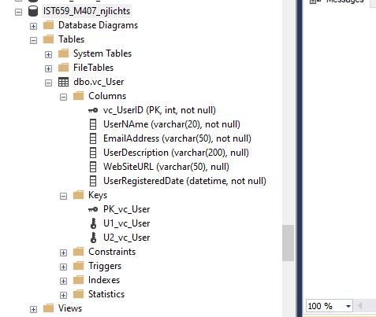

1. User Login Table

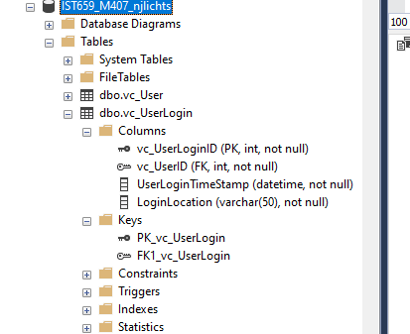

1. User Records

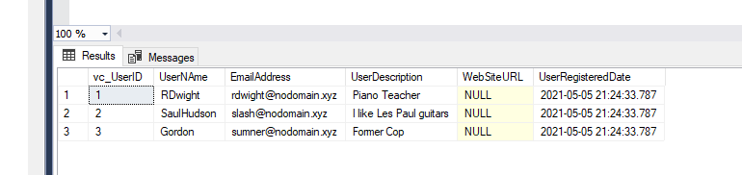

1. User Tables

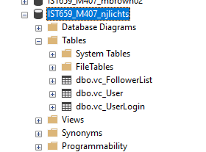

Part 2 - The Rest of the Tables

1. VidCast Tables

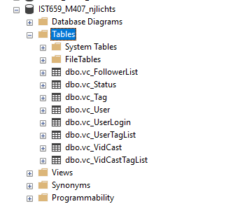

1. SQL Code

/*

Author: Nicholas Lichtsinn

Course: IST659 M407

Term: April, 2021

*/

-- Creating the User Table

CREATE TABLE vc_User (

-- Columns for the User Table

vc_UserID int identity,

UserNAme varchar(20) not null,

EmailAddress varchar(50) not null,

UserDescription varchar(200),

WebSiteURL varchar(50),

UserRegisteredDate datetime not null default GetDate(),

-- Constraints on the User Table

CONSTRAINT PK_vc_User PRIMARY KEY (vc_UserID),

CONSTRAINT U1_vc_User UNIQUE(UserName),

CONSTRAINT U2_vc_User UNIQUE(EmailAddress)

)

-- End Creating the User Table

-- Creating the User Login Table

CREATE TABLE vc_UserLogin (

-- Columns for the User Login Table

vc_UserLoginID int identity,

vc_UserID int not null,

UserLoginTimeStamp datetime not null default GetDate(),

LoginLocation varchar(50) not null,

-- Constraints

CONSTRAINT PK_vc_UserLogin PRIMARY KEY (vc_UserLoginID),

CONSTRAINT FK1_vc_UserLogin FOREIGN KEY (vc_UserID) REFERENCES vc_User(vc_UserID)

)

-- Adding Data to the User Table

INSERT INTO vc_User (UserName, EmailAddress, UserDescription)

VALUES

('RDwight', 'rdwight@nodomain.xyz', 'Piano Teacher'),

('SaulHudson', 'slash@nodomain.xyz', 'I like Les Paul guitars'),

('Gordon', 'sumner@nodomain.xyz', 'Former Cop')

SELECT * FROM vc_User

)

-- Creating the Follower List Table

CREATE TABLE vc_FollowerList (

-- Columns for the Follower List Table

vc_FollowerListID int identity,

FollowerID int not null,

FollowedID int not null,

FollowerSince datetime not null,

-- Constraints on the Follower List Table

CONSTRAINT PK_vc_FollowerList PRIMARY KEY (vc_FollowerListID),

CONSTRAINT U1_vc_FollowerList UNIQUE (FollowerID, FollowedID),

CONSTRAINT FK1_vc_FollowerList FOREIGN KEY (FollowerID) REFERENCES vc_User(vc_UserID),

CONSTRAINT FK2_vc_FollowerList FOREIGN KEY (FollowedID) REFERENCES vc_User(vc_UserID)

)

-- End creating the Follower List Table

-- Creating the Tag Table

CREATE TABLE vc_Tag (

vc_TagID int identity,

TagText varchar(20) not null,

TagDescription varchar(100),

CONSTRAINT PK_vc_Tag PRIMARY KEY (vc_TagID),

CONSTRAINT U1_vc_Tag UNIQUE (TagText)

)

-- Creating the Status Table

CREATE TABLE vc_Status (

vc_StatusID int identity,

StatusText varchar(20),

CONSTRAINT PK_vc_Status PRIMARY KEY (vc_StatusID),

CONSTRAINT U1_vc_Statustext UNIQUE (StatusText)

)

-- Creating the VidCast table

CREATE TABLE vc_VidCast (

vc_VidCastID int identity,

VidCastTitle varchar(50) not null,

StartDateTime datetime,

EndDateTime datetime,

ScheduledDurationMinutes int,

RecordingURL varchar(50),

vc_UserID int not null,

vc_StatusID int not null,

CONSTRAINT PK_vc_VidCast PRIMARY KEY (vc_VidCastID),

CONSTRAINT FK1_vc_VidCast FOREIGN KEY (vc_UserID) REFERENCES vc_User(vc_UserID),

CONSTRAINT FK2_vc_VidCast FOREIGN KEY (vc_StatusID) REFERENCES vc_Status(vc_StatusID)

)

-- Creating the VidCast Tag List Table

CREATE TABLE vc_VidCastTagList (

vc_VidCastTagListID int identity,

vc_TagID int not null,

vc_VidCastID int not null,

CONSTRAINT PK_vc_VidCastTagList PRIMARY KEY (vc_VidCastTagListID),

CONSTRAINT U1_vc_VidCastTagList UNIQUE (vc_TagID, vc_VidCastID),

CONSTRAINT FK1_vc_VidCastTagList FOREIGN KEY (vc_TagID) REFERENCES vc_Tag(vc_TagID),

CONSTRAINT FK2_vc_VidCastTagList FOREIGN KEY (vc_VidCastID) REFERENCES vc_VidCast(vc_VidCastID)

)

-- Creating the User Tag List Table

CREATE TABLE vc_UserTagList (

vc_UserTagListID int identity,

vc_TagID int not null,

vc_UserID int not null,

CONSTRAINT PK_vc_UserTagList PRIMARY KEY (vc_UserTagListID),

CONSTRAINT U1_vc_UserTagList UNIQUE (vc_TagID, vc_UserID),

CONSTRAINT FK1_vc_UserTagList FOREIGN KEY (vc_TagID) REFERENCES vc_Tag(vc_TagID),

CONSTRAINT FK2_vc_UserTagList FOREIGN KEY (vc_UserID) REFERENCES vc_User(vc_UserID)

)